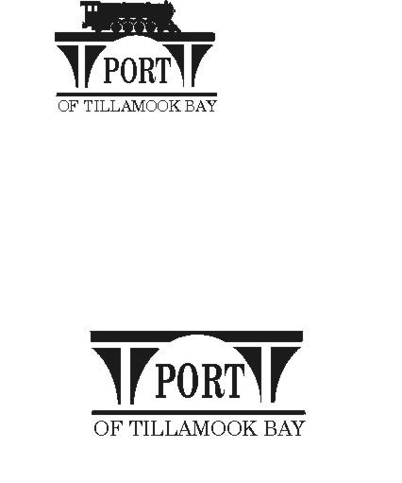

##### AGENDA

**POTB BOARD OF COMMISSIONERS**

**REGULAR MONTHLY MEETING**

**PORT OFFICE, 4000 BLIMP BLVD., TILLAMOOK – CONFERENCE ROOM**

**TUESDAY, JULY 23, 2024 AT 6:00 P.M.**

<https://us02web.zoom.us/j/83129151116?pwd=dkFRM0VsWlk1U04yQnh6UU00ekNndz09>

*Any comments or written testimony, if allowed, may be submitted to* [*mbradley@potb.org*](mailto:mbradley@potb.org) *up to 3:00 pm on the afternoon of the meeting*

1. 6:00 Call to Order, Recognition of Persons Present, and Public Comment for Items Not on the Agenda (2-minute limit, or as Board President Desires)
2. 6:05 Salmonberry Trail - Michelle Jenck, Tillamook County Wellness (15 minutes)
3. 6:20 Discussion and Consideration of Accepting a Grant Award Offer from the Federal Aviation Administration for the Tillamook Airport Master Plan Update, FAA CIP Project 3-41-0060-027-2024 and authorization for the General Manager to sign grant documents **(Action)**
4. Consent Agenda **(Action)**
   1. Minutes for June 20, 2024 Regular Meeting
5. 6:25 Air Museum Director Report – Rita Welch
6. 6:30 Office Administrator Report – Pami Boomer – No Report – vacation/1st of FY
7. 6:40 Manager’s Written Report and Discussion - Michele Bradley
8. 6:55 Board Updates and Written Reports
   * + - 1. SDAO Board Member Training Opportunities:

Board of Director Trainings

Board Member Relations, Expectations, and Ethics

Online Public Meeting Training

1. 7:00 Communications
   1. Board meeting: Wednesday, August 21, 2024, 6:00 pm
   2. Port Offices closed Monday September 2 for Labor Day.
   3. Board meeting: Wednesday, September 18, 2024, 6:00 pm
   4. Board meeting: Wednesday, October 16, 2024, 6:00 pm
2. 7:20 Executive Session per ORS 192.660 (2)(h) To consult with counsel concerning the legal rights and duties of a public body with regard to current litigation or litigation likely to be filed; and ORS 192.660 (2) e) to discuss Real Property Transactions
3. Adjourn