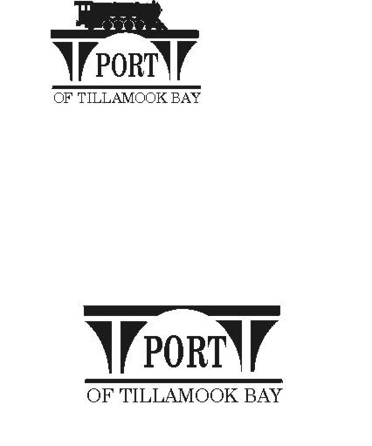

##### AGENDA - AMENDED

**POTB BOARD OF COMMISSIONERS**

**BUDGET HEARING AND REGULAR MONTHLY MEETING**

**PORT OFFICE, 4000 BLIMP BLVD., TILLAMOOK – CONFERENCE ROOM**

**JUNE 20, 2024 AT 6:00 P.M.**

<https://us02web.zoom.us/j/83129151116?pwd=dkFRM0VsWlk1U04yQnh6UU00ekNndz09>

*Any comments or written testimony, if allowed, may be submitted to* [*mbradley@potb.org*](mailto:mbradley@potb.org) *up to 3:00 pm on the afternoon of the meeting*

1. 6:00 Call to Order, Recognition of Persons Present, and Public Comment for Items Not on the Agenda (2-minute limit, or as Board President Desires)
2. 6:10 Presentation: ODOT SMART Grant Project and Discussion of Port being project sponsor – Paul Nesbitt, Chenega Supply Chain Solutions, LLC
3. 6:30 Second Reading and Hearing; Discussion and Consideration of POTB Ordinance #9 Regulating Stormwater Pollution; Prescribing Charges, Rates, and Fees; and Establishing Penalties for Non-compliance **(Action)**
4. 6:35 Discussion and Consideration of POTB Resolution #9, Setting Fees for the Stormwater Utility System Ordinance as Exhibit A **(Action)**
5. 6:40 Consent Agenda **(Action)**
   1. Minutes for May 15, 2024 Regular Meeting
   2. Lease Order #24-17 N222YZ, LLC; Hangar #19; Aircraft Storage; mo. to mo.
   3. Lease Order #24-18 Kevin Bennett; Hangar #15; Aircraft Storage; mo. to mo.
   4. Lease Order #24-19 V & R Aviation, LLC; Hangar #18; Aircraft Storage mo. to mo.
   5. Lease Order #24-20 V & R Aviation, LLC; Hangar #4; Aircraft Storage mo. to mo.
6. 6:45 Air Museum Director Report – Rita Welch
7. 6:50 Office Administrator Report – Pami Boomer
   1. Capital outlay
   2. Financials
8. 7:00 Manager’s Written Report and Discussion - Michele Bradley
9. 7:10 Board Updates and Written Reports
10. 7:15 Communications
    1. Port Offices closed Wednesday, June 19 for the Juneteenth holiday.
    2. Port Offices closed Thursday, July 4 for the holiday.
    3. **Board meeting: Tuesday, July 23, 2024 board meeting, 6:00 pm**
    4. Board meeting: Wednesday, August 21, 2024, 6:00 pm
    5. Port Offices closed Monday September 2 for Labor Day.
    6. Board meeting: Wednesday, September 18, 2024, 6:00 pm
11. 7:20 Executive Session per ORS 192.660 (2)(h) To consult with counsel concerning the legal rights and duties of a public body with regard to current litigation or litigation likely to be filed.
12. Adjourn Goal: 7:30 or before