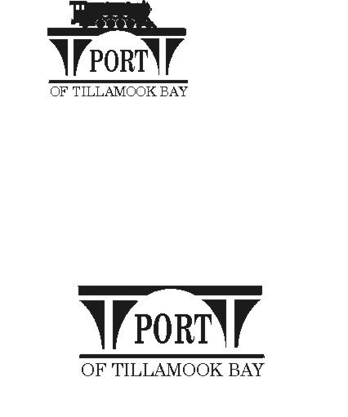

##### AGENDA

**POTB BOARD OF COMMISSIONERS**

**REGULAR MONTHLY MEETING**

**PORT OFFICE, 4000 BLIMP BLVD., TILLAMOOK – CONFERENCE ROOM**

**WEDNESDAY, DECEMBER 18, 2024 AT 6:00 P.M.**

<https://us02web.zoom.us/j/84077124356?pwd=KzRTVFUwbGxjS1hiZ205SzJwS3hUZz09>

*Any comments or written testimony, if allowed, may be submitted to* [*mbradley@potb.org*](mailto:mbradley@potb.org) *up to 3:00 pm on the afternoon of the meeting*

1. 6:00 Call to Order, Recognition of Persons Present, and Public Comment for Items Not on the Agenda (2-minute limit, or as Board President Desires)
   1. Recognition of Margaret Amick and her service to the Port at her last board meeting
2. 6:05 Update from Hangar Project Consultant, Alana Kambury (15 minutes)
   1. Timeline review
3. 6:25 Review Contract Recommendations with Jim Knight, SDAO Consultant, regarding General Manager Contract updates **(Action)** (15 minutes)
4. 7:00 Consent Agenda **(Action)**
   * 1. Minutes for November 18, 2024 Regular Meeting and November 18, 2024 Board Workshop
     2. Lease Order #24-31 Ken Werner, dba Werner Gourmet Meat Snacks, Inc.; Warehouse A Bldg. 59, 6005 B Street; Warehousing; mo. to mo.
5. 7:05 Office Administrator Report – Pami Boomer
   1. Confirm January meeting for budget notice
6. 7:20 Air Museum Director Report – Rita Welch
   1. KAPLA Update
7. 7:30 Discussion and Consideration of Accepting the Updated Disadvantaged Business Enterprise (DBE) Program as required for the Federal Aviation Administration, and authorization for Jack Mulder to sign **(Action)**
8. 7:40 Discussion and Consideration of Grant No. LG24-061 with Oregon Parks and Recreation Department for Disc Golf Course Improvements for Blimp Base Disc Golf Course and Recreation Area for $57,449, and Authorization for General Manager to sign all grant documents **(Action)**
9. 7:45 Discussion and Consideration of Amendment 1 to Resolution #1 for 2024-2025 **(Action)**
10. 7:55 Discussion and Consideration of Sponsoring a Grant Application for funding for the Partners for Rural Food Systems Kitchen and Food Hub to be located at the Port **(Action)**
11. 8:00 Manager’s Written Report and Discussion - Michele Bradley
    1. Process for Manager Annual review in January
    2. Process for 2025 Goal Setting
12. 8:15 Board Updates and Discussion
13. 8:20 Communications
    1. Closed Christmas Holiday: December 25 and New Years Day
    2. Board Meeting: Wednesday, January 15, 2025 at 6:00 pm
    3. Closed for MLK Holiday January 20, 2025
    4. SDAO Annual Conference February 6 – 9, 2025
    5. Closed for President’s Day Holiday February 17, 2025
    6. Board Meeting: Wednesday, February 19, 2025 at 6:00 pm
14. 8:25 Executive Session per ORS 192.660 (2)(h) To consult with counsel concerning the legal rights and duties of a public body with regard to current litigation or litigation likely to be filed; and ORS 192.660 (2) (e) to discuss Real Property Transactions
15. Adjournment