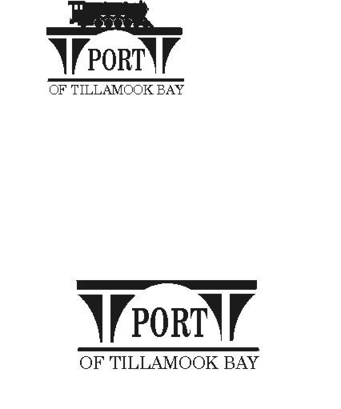

##### AGENDA

**POTB BOARD OF COMMISSIONERS**

**REGULAR MONTHLY MEETING**

**PORT OFFICE, 4000 BLIMP BLVD., TILLAMOOK – CONFERENCE ROOM**

**WEDNESDAY, AUGUST 21, 2024 AT 6:00 P.M.**

<https://us02web.zoom.us/j/83129151116?pwd=dkFRM0VsWlk1U04yQnh6UU00ekNndz09>

*Any comments or written testimony, if allowed, may be submitted to* [*mbradley@potb.org*](mailto:mbradley@potb.org) *up to 3:00 pm on the afternoon of the meeting*

1. 6:00 Call to Order, Recognition of Persons Present, and Public Comment for Items Not on the Agenda (2-minute limit, or as Board President Desires)
2. 6:05 Consent Agenda **(Action)**
   * 1. Minutes for July 23, 2024 Regular Meeting
     2. Lease Order #24-21 Dairy Specialists, LLC; Bldg. #11, Unit L; Warehousing and Distribution; mo. to mo.
     3. Lease Order #24-22 Brittney Bakes; Bldg. #54, Hangar B Café; Food Service/ Catering; mo. to mo.
3. 6:10 Action Items:
   1. Discussion and Consideration of Resolution 2024-2025 #2, considering certain property as surplus within the industrial park **(Action)**
   2. If available: Discussion and Consideration of Accepting Grant 2023-TMK-00034 from the Oregon Department of Aviation COAR Grant program as match funding for the FAA Fuel Systems Grant **(Action)**
4. 6:20 Air Museum Director Report – Rita Welch – no written report
5. 6:21 Office Administrator Report – Pami Boomer – will send via email
6. 6:22 Manager’s Written Report and Discussion - Michele Bradley
7. 6:45 Board Updates
8. 6:50 Communications
   1. Port Offices closed Monday September 2 for Labor Day.
   2. Board meeting: Wednesday, September 18, 2024, 6:00 pm
   3. Board meeting: Wednesday, October 16, 2024, 6:00 pm
9. 6:55 Executive Session per ORS 192.660 (2)(h) To consult with counsel concerning the legal rights and duties of a public body with regard to current litigation or litigation likely to be filed; ORS 192.660 (2) (i) to discuss the evaluation of a public employee; and ORS 192.660 (2) (e) to discuss Real Property Transactions
10. Adjourn