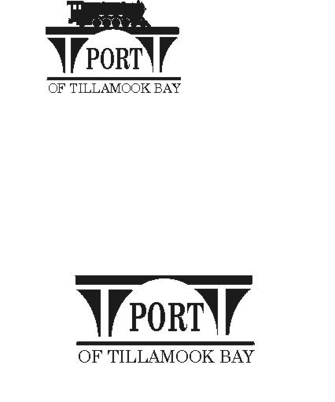

##### AGENDA

**POTB BOARD OF COMMISSIONERS**

**REGULAR MONTHLY MEETING**

**PORT OFFICE, 4000 BLIMP BLVD., TILLAMOOK – CONFERENCE ROOM**

**MONDAY, SEPTEMBER 23, 2024 AT 6:00 P.M.**

<https://us02web.zoom.us/j/84077124356?pwd=KzRTVFUwbGxjS1hiZ205SzJwS3hUZz09>

*Any comments or written testimony, if allowed, may be submitted to* [*mbradley@potb.org*](mailto:mbradley@potb.org) *up to 3:00 pm on the afternoon of the meeting*

1. 6:00 Call to Order, Recognition of Persons Present, and Public Comment for Items Not on the Agenda (2-minute limit, or as Board President Desires)
2. 6:05 Brief Presentation: Ballot Measure 29-180 – County GO Bond to upgrade and replace the public safety radio system – Tillamook County Commissioner Doug Olson
3. 6:20 Consent Agenda **(Action)**
   * 1. Minutes for August 21, 2024 Regular Meeting
     2. Lease Order #24-23 Lylajean Walters; Hangar #25 – TMK; Aircraft Storage; mo. to mo.
     3. Lease Order #24-24 Tillamook Distributing, LLC; Bldg. #11, Unit H; Warehousing/Distribution; mo. to mo.
     4. Lease Order #24-25 Don G. Averill Recycling, Inc; 4 acres land; Automotive salvage and recycling, wood waste and bovine mortality; 2 years transitioning to mo. to mo.
4. 6:25 Air Museum Director Report – Rita Welch
   * 1. Café tenant – Grand Opening October 3rd at 9:00 am – Chamber Ribbon Cutting
     2. Restitution received
     3. FOTAM IRS status
     4. Documentary opportunity
5. 6:35 Office Administrator Report – Pami Boomer
   * 1. Board Member Login – emailed for SDAO Trainings
     2. Staff Changes
6. 6:45 Manager’s Written Report and Discussion - Michele Bradley
   1. Oregon Department of Energy (ODOE) Grant received $100,000 plus $15,000 for EV Chargers and vehicles (detail in written report)
   2. Oregon Parks and Recreation Department (OPRD) Local Government Grant approved for $57,449 for Blimp Base Disc Golf Course Project, Phase II
7. 7:00 Board Updates
8. Communications
   1. **Ribbon Cutting for Brittney Bakes at the Air Museum: Thursday, October 3rd, 2024 at 9:00 am.**
   2. Board meeting: Wednesday, October 16, 2024, 6:00 pm
   3. **Board workshop: Tuesday, October 22, 2024, 2:00 – 3:30 pm**
   4. Board meeting: Wednesday, November 20, 2024, 6:00 pm
   5. Closed Thanksgiving Holiday: November 28 and 29
   6. Board meeting: Wednesday, December 18, 2024, 6:00 pm
   7. Closed Christmas Holiday: December 25
   8. Closed New Years Day
   9. SDAO Annual Conference, Bend, February 7-9, 2025
9. Executive Session per ORS 192.660 (2)(h) To consult with counsel concerning the legal rights and duties of a public body with regard to current litigation or litigation likely to be filed; and ORS 192.660 (2) (e) to discuss Real Property Transactions
10. Adjourn